#include <stdio.h>

int linearSearch(int arr[], int size, int key) {

    for (int i = 0; i < size; i++) {

        if (arr[i] == key) {

            return i;

        }   }

    return -1; }

int main() {

    int n, key;

    printf("Enter the number of elements in the array: ");

    scanf("%d", &n);

    int arr[n];

    printf("Enter %d elements:\n", n);

    for (int i = 0; i < n; i++) {

        scanf("%d", &arr[i]); }

    printf("Enter the element to search for: ");

    scanf("%d", &key);

    int result = linearSearch(arr, n, key);

    if (result == -1) {

        printf("Element not found\n"); }

    else {

        printf("Element found at index: %d\n", result); }

    return 0;

}

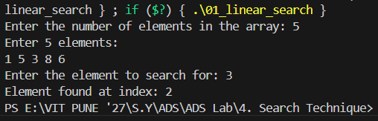

#include <stdio.h>

int binarySearch(int arr[], int size, int key) {

    int left = 0;

    int right = size - 1;

    while (left <= right) {

        int mid = left + (right - left) / 2;

        if (arr[mid] == key) { return mid; }

        if (arr[mid] < key) { left = mid + 1;  }

else { right = mid – 1; } }

    }  return -1;

}

int main() {

    int n, key;

    printf("Enter the number of elements in the array: ");

    scanf("%d", &n); int arr[n];

    printf("Enter %d sorted elements:\n", n);

    for (int i = 0; i < n; i++) {

        scanf("%d", &arr[i]); }

    printf("Enter the element to search for: ");

    scanf("%d", &key);

    int result = binarySearch(arr, n, key);

    if (result != -1) { printf("Element found at index: %d\n", result);

    } else { printf("Element not found\n") }

    return 0; }

}